ABSTRACT

Urban flooding and sanitation worker safety are two major challenges faced by modern cities due to poor drainage management and lack of monitoring systems. Traditional drainage systems rely heavily on manual inspection, which is inefficient, time-consuming, and hazardous to workers. In many cases, drain blockages go unnoticed until flooding occurs, causing damage to infrastructure, public inconvenience, and environmental pollution.
This project presents SafeDrain: Smart Waste & Drain Monitoring System, an IoT-based solution designed to monitor drainage conditions in real time and ensure worker safety. The system integrates multiple sensors such as ultrasonic sensors for water level detection, gas sensors for detecting toxic gases, and IR sensors for identifying blockages. These sensors continuously collect data and send it to a microcontroller (ESP32), which processes the data and displays it on a centralized monitoring dashboard.
In addition to drain monitoring, the system includes a wearable safety device for sanitation workers. This device monitors vital parameters such as heart rate, body temperature, and movement, and includes a panic button for emergency situations. Alerts are generated automatically when abnormal conditions are detected, enabling quick response from authorities.
The proposed system aims to reduce flood risks, improve maintenance efficiency, and enhance worker safety. It is cost-effective, scalable, and suitable for smart city applications. Overall, SafeDrain provides a practical and innovative solution for urban infrastructure management.

 | INDEX
S.NO | CONTENTS |  |  | PAGE NO
 | ABSTRACT |  |  | IV
 | LIST OF FIGURES |  |  | VI
1 | INTRODUCTION |  |  | 1
 | 1.1 Smart Urban Infrastructure Monitoring |  |  | 1
 | 1.2 Objectives |  |  | 2
2 | EXISTING METHODOLOGY |  |  | 4
 | 2.1 Existing System |  |  | 4
 | 2.2 Limitations |  |  | 4
 | 2.3 Related Work  2.4 Inference |  |  | 7  10
3 | PROPOSED SYSTEM |  |  | 8
 | 3.1 Overview of the Proposed System |  |  | 8
 | 3.2 System Architecture |  |  | 9
 | 3.3 Hardware Configuration and Component Selection |  |  | 11
 | 3.4 Software Framework and Development Environment |  |  | 14
 | 3.5 Methodology  3.6 Feasibility and Viability |  |  | 15
4 | RESULTS AND DISCUSSION |  |  | 21
 | 4.1 System Implementation |  |  | 21
 | 4.2 Performance Analysis |  |  | 22
 | 4.3 Discussion |  |  | 26
5 | FUTURE SCOPE AND CONCLUSION |  |  | 30
 | 5.1 Future Scope |  |  | 30
 | 5.2 Conclusion |  |  | 33
 | REFERENCES |  |  | 34
FIG NO. |  |  | TITLE | PAGE NO
3.1 |  | System Architecture of SafeDrain |  | 10
3.2 |  | Ultrasonic Sensor |  | 13
3.3 |  | IR Sensor |  | 13
3.4 |  | Gas Sensor |  | 13
3.5 |  | Pulse Sensor |  | 13
3.6 |  | Temperature Sensor |  | 14
3.7 |  | Motion Sensor |  | 14
3.8 |  | ESP32 Module |  | 18
3.9 |  | Arduino UNO Board |  | 24
3.10 |  | Design of Smart Drain |  | 24
4.1 |  | Block Diagram of SafeDrain System |  | 25
4.2 |  | Real-Time Drain Monitoring Dashboard |  | 25
4.3 |  | Water Level Variation Graph |  | 27
4.4 |  | Gas Detection Alert Visualization |  | 27
4.5 |  | Worker Health Monitoring Interface |  | 29
4.6 |  | Heatmap Visualization of Risk Zones |  | 29

CHAPTER 1

INTRODUCTION

1.1 Smart Urban Infrastructure Monitoring
Urbanization has significantly transformed modern cities, leading to increased population density, rapid infrastructure development, and higher demand for efficient public services. Among the critical components of urban infrastructure, drainage systems play a vital role in maintaining environmental hygiene and preventing water accumulation. However, improper waste disposal, lack of continuous monitoring, and inefficient maintenance often result in clogged drains and water overflow, which can disrupt normal city operations and pose serious risks to public safety.
In addition to infrastructure challenges, sanitation workers responsible for maintaining these drainage systems are frequently exposed to hazardous working conditions. These include contact with toxic gases, contaminated water, and physically unsafe environments. Prolonged exposure to such conditions can lead to severe health issues and, in extreme cases, life-threatening situations. The absence of real-time monitoring systems and safety mechanisms further increases the vulnerability of these workers.
Traditional methods of drainage monitoring rely heavily on manual inspection and reactive maintenance approaches. These methods are not only time-consuming but also inefficient in detecting issues at an early stage. As a result, problems such as blockages or rising water levels are often identified only after they escalate into critical situations.
Advancements in the Internet of Things (IoT) have opened new possibilities for addressing these challenges. IoT enables the integration of sensors, embedded systems, and communication technologies to facilitate real-time data collection and monitoring. By deploying smart sensing units in drainage systems, it becomes possible to continuously track environmental conditions, detect anomalies, and generate timely alerts.
Therefore, the adoption of smart urban infrastructure monitoring systems is essential to enhance operational efficiency, improve safety standards, and support sustainable city development. Such systems not only enable proactive maintenance but also contribute to the creation of resilient and intelligent urban environments.
1.2 Objectives
The primary objective of the SafeDrain system is to design and implement an intelligent, IoT-based monitoring framework that enhances the efficiency of urban drainage systems while ensuring the safety and well-being of sanitation workers. The system focuses on integrating real-time sensing, data processing, and alert mechanisms to enable proactive infrastructure management.
The detailed objectives of the project are as follows:
- To develop a robust and reliable IoT-based system for continuous monitoring of drainage conditions in urban environments
- To measure and track water levels in drains using ultrasonic sensors, enabling early detection of overflow and flood-prone situations
- To identify blockages and waste accumulation using IR sensors, thereby supporting timely cleaning and maintenance operations
- To detect the presence of hazardous gases such as methane and carbon monoxide using gas sensors to prevent unsafe working conditions
- To design and implement a wearable safety band for sanitation workers that monitors vital parameters such as heart rate, body temperature, and physical activity
- To incorporate a panic button in the wearable device for immediate emergency alerts in critical situations
- To establish a real-time communication system that transmits sensor data to a centralized monitoring platform
- To develop a user-friendly dashboard that visually represents drainage conditions and worker health status using graphs and heatmaps
- To implement threshold-based alert mechanisms that notify authorities when abnormal conditions such as high water levels, toxic gas presence, or abnormal worker vitals are detected
- To enhance decision-making capabilities of municipal authorities by providing accurate and real-time data insights
- To reduce response time in emergency situations through automated alerts and continuous monitoring
- To ensure system scalability so that it can be deployed from a small area to a city-wide infrastructure network
- To design a cost-effective solution using affordable hardware components, making it suitable for large-scale municipal implementation
- To improve overall public safety by minimizing flood risks and ensuring safe working conditions for sanitation workers
- To support smart city initiatives by integrating modern IoT technologies into urban infrastructure management systems
The overall objective of the SafeDrain system is to create a sustainable, efficient, and intelligent solution that bridges the gap between infrastructure monitoring and human safety, contributing to the development of safer and more resilient cities.

CHAPTER 2

EXISTING METHODOLOGY

2.1 Existing System
In conventional urban infrastructure management, drainage systems are primarily monitored through manual inspection and routine maintenance practices carried out by municipal authorities. Sanitation workers are responsible for physically examining drainage lines, manholes, and pipelines to identify issues such as blockages, sediment accumulation, and structural damage. These inspections are typically scheduled periodically or triggered only when visible problems such as water stagnation, foul odor, or overflow occur.
The maintenance process involves opening manholes, manually removing waste materials, and ensuring that water flows smoothly through the drainage network. In some cases, mechanical tools or suction machines are used for cleaning; however, the overall process still depends heavily on human involvement. The lack of automation makes the system slow and inefficient, particularly in densely populated urban areas.
In certain developed cities, advanced systems such as CCTV-based inspection and centralized monitoring stations have been introduced. These systems use cameras and sensors to inspect underground pipelines and detect structural defects. However, such solutions are expensive, require specialized infrastructure, and are not widely implemented in developing regions due to high installation and maintenance costs.
Moreover, existing systems do not continuously monitor key environmental parameters such as water level, gas concentration, or flow rate. Data collection is not real-time and is often recorded manually or based on observation. This limits the ability of authorities to make timely and informed decisions.
Another critical aspect of the existing methodology is the lack of worker safety integration. Sanitation workers often enter confined spaces such as manholes without proper monitoring of toxic gases or environmental conditions. Exposure to gases like methane, hydrogen sulfide, and carbon monoxide can lead to serious health hazards, including suffocation and poisoning. Despite the risks, there are limited technological interventions to ensure worker safety during such operations.
Overall, the current system is reactive in nature, addressing problems only after they occur rather than preventing them in advance. This leads to inefficiencies in urban management and increases the risk of accidents and environmental damage.

2.2 Limitations
The traditional drainage monitoring and maintenance systems exhibit several significant limitations that affect their effectiveness, safety, and scalability:
Absence of Continuous Monitoring:
The lack of automated sensing mechanisms prevents continuous tracking of drainage conditions, resulting in delayed detection of critical issues.
Reactive Maintenance Approach:
Maintenance activities are performed only after problems become visible, leading to increased chances of flooding and infrastructure damage.
Manual Dependency and Human Error:
Heavy reliance on human labor introduces the possibility of errors, inconsistencies, and inefficiencies in inspection and maintenance processes.
Unsafe Working Conditions:
Workers are exposed to hazardous environments without real-time monitoring of toxic gases or health parameters, increasing the risk of accidents and fatalities.
No Early Warning System:
The absence of alert mechanisms makes it difficult to provide timely warnings for rising water levels, blockages, or dangerous gas accumulation.
Lack of Data Integration:
Data is not systematically collected, stored, or analyzed, resulting in poor decision-making and lack of historical insights
Inefficient Resource Allocation:
Without proper data analysis, maintenance activities are not prioritized based on risk levels, leading to wastage of time and resources.
High Operational Costs in the Long Term:
Although manual systems appear low-cost initially, repeated labor, emergency repairs, and damage recovery increase long-term expenses.
Limited Technological Adoption:
Many existing systems do not utilize modern technologies such as IoT, cloud computing, or data analytics, limiting their efficiency and scalability.
Difficulty in Large-Scale Implementation:
Managing drainage systems in large cities using manual methods becomes increasingly complex and impractical.
2.3 Related Work
Several research studies and technological developments have attempted to improve drainage monitoring and flood prevention using modern approaches:
- IoT-Based Flood Monitoring Systems:
Researchers have developed systems using water level sensors and wireless communication to detect rising water levels and provide alerts. These systems demonstrate the potential of real-time monitoring but often focus only on flood detection without addressing worker safety.
- Smart Drainage Monitoring Systems:
Some studies propose the use of sensor networks to monitor drainage conditions, including flow rate and blockage detection. These systems improve efficiency but may lack integration with centralized dashboards or advanced analytics.
- Gas Detection Systems for Worker Safety:
Separate safety systems have been designed to detect toxic gases in confined spaces. While effective, these systems are often standalone and not integrated with drainage monitoring solutions.
- IoT and Edge Computing in Smart Cities:
Recent advancements include the use of IoT combined with edge computing for real-time data processing and faster decision-making. These systems highlight the importance of decentralized processing but may involve higher complexity and cost.

2.4 Inference
The analysis of existing methodologies and related work clearly indicates that current drainage monitoring systems are inadequate in addressing the combined challenges of infrastructure management and worker safety. While some technological solutions exist, they often focus on individual aspects such as flood detection or gas monitoring, lacking a unified approach.
There is a significant gap in integrating multiple functionalities into a single system that can provide real-time monitoring, early warning, and safety assurance simultaneously. Additionally, the absence of scalable and cost-effective solutions limits the adoption of advanced technologies in many urban regions.
To overcome these limitations, a comprehensive system that combines IoT-based sensing, real-time data processing, centralized monitoring, and worker safety mechanisms is required. Such a system can transform traditional reactive approaches into proactive and intelligent solutions, improving efficiency, reducing risks, and supporting sustainable urban development.
Furthermore, the analysis highlights that the lack of integration between infrastructure monitoring and worker safety systems remains a critical gap in existing solutions. Most current approaches treat drainage management and worker protection as separate problems, which reduces overall system effectiveness. In practical scenarios, both aspects are closely interconnected, as unsafe environmental conditions directly impact worker health and operational efficiency. Therefore, a unified system that combines real-time drain monitoring with worker safety mechanisms is essential. Such integration not only improves situational awareness but also enables coordinated decision-making, reduces risks, and enhances overall system reliability. This reinforces the need for a comprehensive IoT-based solution that bridges the gap between environmental monitoring and human safety while supporting scalable and intelligent urban management.

CHAPTER 3

PROPOSED SYSTEM
3.1 Overview of the Proposed System
The SafeDrain system is designed as an advanced Internet of Things (IoT)-based solution aimed at improving urban drainage management while ensuring the safety of sanitation workers. The system addresses the limitations of conventional monitoring approaches by introducing real-time sensing, intelligent data processing, and centralized monitoring.
The proposed system integrates two major subsystems: a smart drain monitoring unit and a worker safety wearable device. The drain monitoring unit is installed within drainage systems to continuously observe environmental parameters such as water level, blockage status, and gas concentration. Simultaneously, the wearable device tracks the physiological condition of sanitation workers operating in hazardous environments.
The system enables continuous monitoring and early detection of abnormal conditions. When critical thresholds are exceeded, such as high water levels, gas leakage, or abnormal worker vitals, the system generates alerts and notifies authorities. This proactive approach helps prevent flooding, reduces operational delays, and minimizes risks to human life.
The SafeDrain system is designed with modularity and scalability in mind. It can be deployed in small regions such as individual streets or expanded to cover large urban areas. The integration of IoT technology ensures seamless communication between hardware components and the monitoring platform, making the system efficient, reliable, and suitable for smart city applications.

3.2 System Architecture
The system architecture of SafeDrain follows a multi-layered IoT model, ensuring clear separation of functionalities and efficient data flow. The architecture consists of the following layers:

3.2.1 Sensing Layer
The sensing layer forms the foundation of the system, responsible for capturing real-time data from both the drainage environment and sanitation workers.
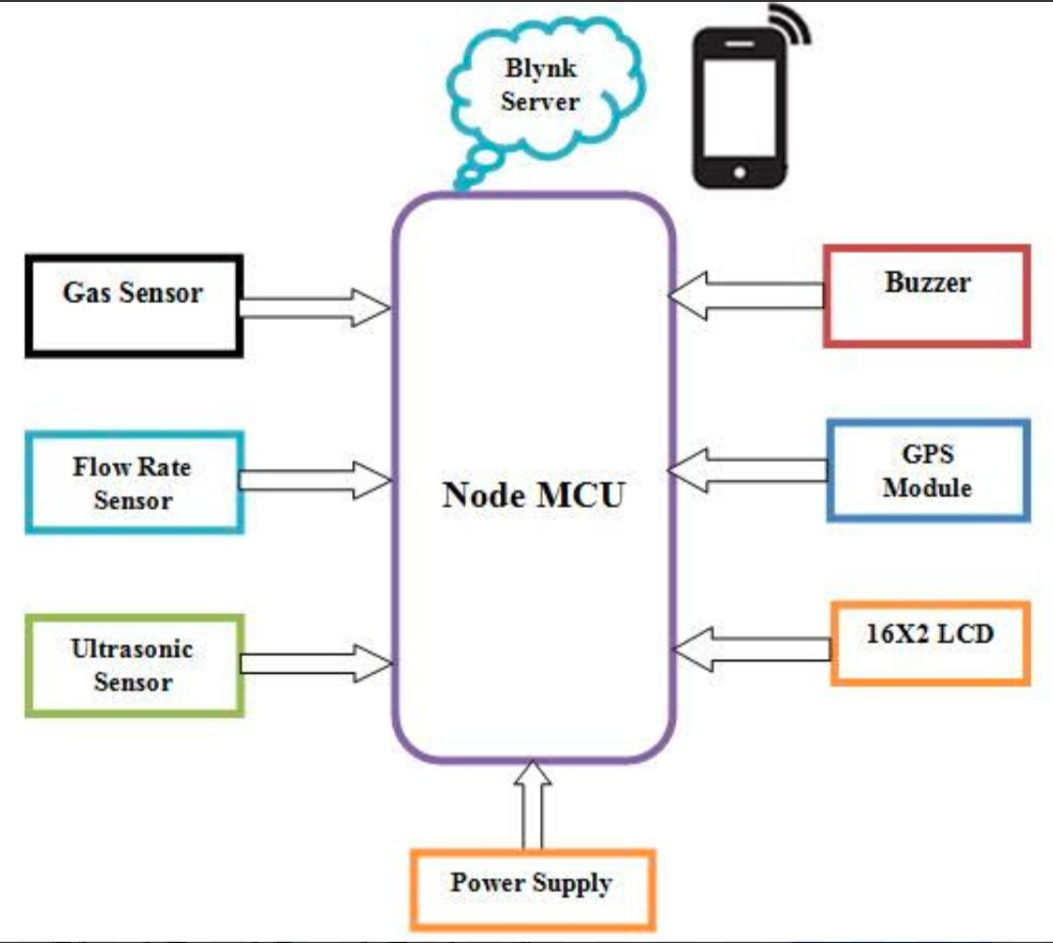
Figure 3.1 System Architecture
- Ultrasonic Sensor:
Measures the distance between the sensor and water surface to determine water level. This helps detect rising water levels and potential overflow conditions.
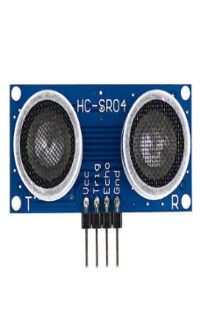
Figure 3.2 Ultrasonic Sensor
- IR Sensor:
Detects the presence of solid waste or blockages within drains by identifying interruptions in infrared signals.
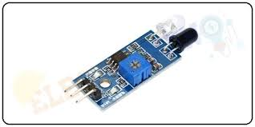
Figure 3.3 IR Sensor

- Gas Sensor:
Monitors harmful gases such as methane, carbon monoxide, and hydrogen sulfide, which are commonly present in drainage systems.
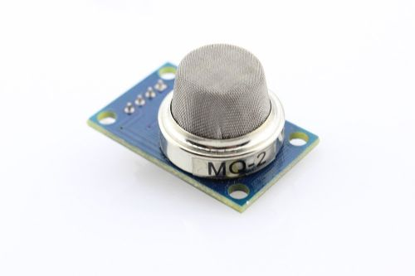
Figure 3.4 Gas Sensor
- Pulse Sensor:
Tracks the heart rate of sanitation workers to ensure their physical well-being.
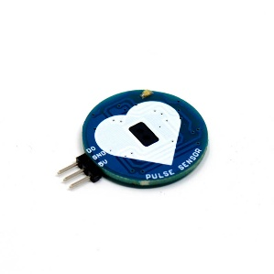
Figure 3.5 Pulse Sensor
- Temperature Sensor:
Measures body temperature to detect abnormal health conditions.
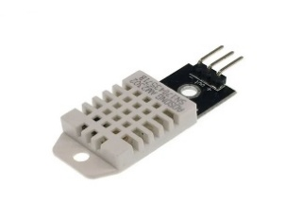
Figure 3.6 Temperature Sensor
- Motion Sensor:
Monitors worker movement to detect inactivity or possible accidents.
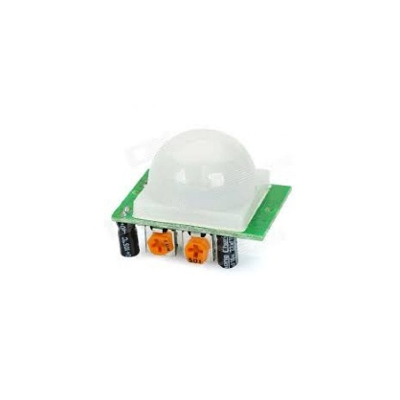
Figure 3.7 Motion Sensor
These sensors operate continuously and provide time-based data for analysis.

3.2.2 Processing Layer
The processing layer acts as the control unit of the system, responsible for data acquisition and analysis.
- The ESP32 and Arduino microcontrollers collect sensor data
- Analog signals are converted into digital values using ADC
- Data filtering techniques are applied to remove noise and fluctuations
- Threshold-based algorithms are implemented to identify abnormal conditions
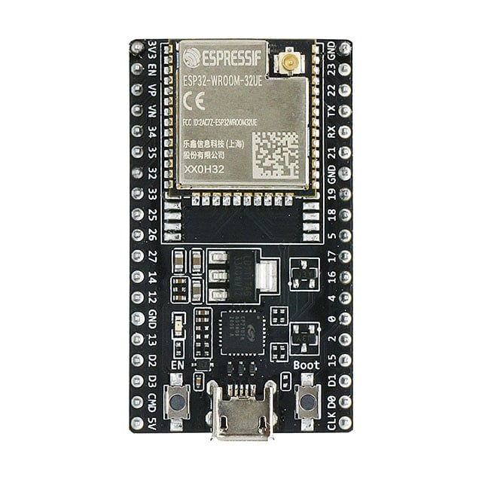
Figure 3.8 ESP32 Module

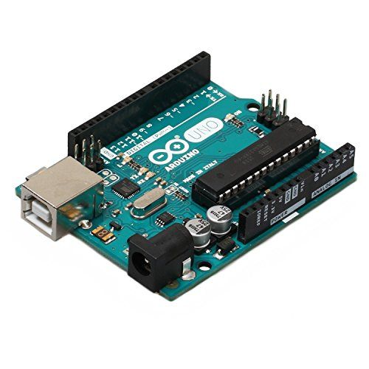
Figure 3.9 Arduino UNO R3
For example:
- High water level → Flood alert
- Gas detection → Safety alert
- Abnormal heart rate → Health alert
This layer ensures accurate and reliable decision-making at the device level.

3.2.3 Communication Layer
The communication layer ensures seamless data transfer between the monitoring units and the application system.
- Utilizes Wi-Fi connectivity (ESP32) for data transmission
- Data packets are formatted and transmitted periodically
- Supports real-time updates with minimal latency
In prototype mode, the system can operate locally, while in real deployment, it can be connected to cloud platforms for large-scale monitoring.

3.2.4 Application Layer
The application layer provides a user interface for monitoring and decision-making.
- Web-based dashboard for real-time visualization
- Displays sensor data using graphs and charts
- Heatmap representation for identifying high-risk zones
- Alert notifications for critical conditions
This layer enables authorities to monitor multiple locations simultaneously and respond effectively

3.3 Hardware Configuration and Component Selection
The hardware configuration of the SafeDrain system is designed to ensure cost-effectiveness, reliability, and efficient real-time monitoring of drainage conditions along with worker safety. The selection of components focuses on ease of integration, availability, and performance in harsh environmental conditions such as wet and polluted drainage systems.
At the core of the system is the microcontroller unit, such as the ESP32 or Arduino UNO, which acts as the main processing and control unit. These microcontrollers are chosen due to their low power consumption, sufficient processing capability, and compatibility with multiple sensor modules. They are responsible for collecting, processing, and transmitting data from various sensors.
The sensing subsystem consists of multiple sensors for monitoring environmental parameters. The ultrasonic sensor is used to measure water levels by calculating the distance between the sensor and the water surface, enabling early detection of overflow conditions. The IR sensor is used to detect blockages or waste accumulation within the drainage system, ensuring timely maintenance.
To enhance safety, a gas sensor is incorporated to detect hazardous gases such as methane and carbon monoxide, which are commonly present in drainage environments. This helps prevent dangerous exposure for sanitation workers.
For worker safety monitoring, a wearable device is designed with multiple sensors. A pulse sensor measures heart rate, a temperature sensor monitors body temperature, and a motion sensor tracks movement or inactivity, which may indicate emergency conditions. In addition, a push button is included to allow workers to send immediate distress signals during critical situations.
Supporting components such as voltage regulators, power supply units, connecting wires, and circuit boards ensure stable operation and proper interfacing between all modules. The overall hardware design is modular, allowing easy maintenance, upgrades, and scalability for larger deployments.
Although low-cost sensors may have certain limitations in accuracy, proper calibration and signal conditioning techniques improve their performance, making the system reliable and suitable for practical urban applications.

3.4 Software Framework and Development Environment
The software framework of the SafeDrain system is designed to support real-time data acquisition, processing, communication, and visualization. It integrates embedded programming with web-based application development to ensure seamless interaction between hardware components and the user interface. The overall software architecture is modular, allowing easy updates, scalability, and efficient system performance.
The embedded software is developed using the Arduino IDE, which provides a simple and flexible environment for programming microcontrollers such as Arduino UNO and ESP32. The programming is carried out using Embedded C, which allows direct interaction with hardware components and efficient control of sensor operations. The code is structured to continuously read sensor inputs, process the data, and execute necessary actions based on predefined conditions.
Data acquisition is performed by collecting readings from all connected sensors at regular intervals. These raw sensor values are then calibrated and converted into meaningful units, such as distance for water level, gas concentration levels, and physiological parameters like heart rate and temperature. Basic filtering techniques are applied to remove noise and fluctuations, ensuring stable and accurate readings.
The system implements threshold-based logic to detect abnormal conditions. For example, if the water level exceeds a certain limit, a flood alert is generated; if harmful gases are detected, a safety warning is triggered; and if worker health parameters deviate from normal ranges, an emergency alert is activated. These decision-making processes are handled within the microcontroller to ensure quick response without delay.
The communication between the hardware and the monitoring platform is managed using the Wi-Fi capabilities of the ESP32 module. The processed data is transmitted in structured format to a local server or web-based application. This enables real-time data synchronization and remote monitoring of the system.
On the application side, a web-based dashboard is developed to display the collected data in an intuitive and user-friendly manner. The dashboard presents information through graphs, charts, and status indicators, allowing authorities to easily understand the condition of drainage systems and worker safety. Heatmap visualization is used to represent different risk levels across various locations, helping in identifying critical zones quickly.
The software system also includes alert mechanisms that notify users when abnormal conditions are detected. These alerts can be displayed on the dashboard and can be extended to notifications through mobile or other communication systems in future enhancements.
Overall, the software framework is designed to ensure reliability, real-time performance, and ease of use. Its modular structure allows integration with advanced technologies such as cloud computing, mobile applications, and artificial intelligence in future developments, making the system adaptable for smart city applications.
3.5 Design and Implementation Strategy
The design and implementation of the SafeDrain system follow a systematic and structured approach to ensure reliability, efficiency, and ease of deployment. The process begins with identifying the system requirements, defining objectives, and selecting appropriate hardware and software components based on functionality, cost, and environmental suitability. A detailed system architecture and block diagram are prepared to clearly represent the interaction between sensors, microcontrollers, communication modules, and the monitoring dashboard.
In the initial design phase, emphasis is placed on selecting suitable sensors for accurate detection of water levels, blockages, gas presence, and worker health parameters. The placement of sensors within the drainage system and wearable device is carefully planned to ensure maximum coverage and reliable data collection. The microcontroller is chosen based on its processing capability and communication features, ensuring smooth integration with all components.
During the hardware implementation phase, all selected components are interconnected using appropriate circuits. Each sensor is individually tested to verify its functionality and accuracy before integration into the complete system. Proper power management is ensured using regulated power supplies to maintain stable operation. The wearable safety device is designed to be lightweight and comfortable for workers, while still housing all necessary sensors and alert mechanisms.
The software development phase involves writing embedded code for data acquisition, processing, and decision-making. The program is designed to continuously read sensor values, apply calibration and filtering techniques, and compare the results with predefined threshold limits. Based on these conditions, the system determines whether the environment is normal or critical and triggers alerts accordingly. The code is structured in a modular manner to allow easy debugging and future enhancements.
In the communication setup phase, the ESP32 module is configured to enable wireless data transmission. The system is designed to send real-time data to a local server or web-based dashboard. Data packets are formatted systematically to ensure accurate interpretation at the receiving end. This phase ensures that the system can operate both in offline (local monitoring) and online (remote monitoring) modes.
The dashboard development phase focuses on creating a user-friendly interface that displays sensor data in an understandable format. Graphs, indicators, and heatmaps are used to represent real-time conditions of drains and worker health. Alert systems are integrated into the dashboard to notify authorities when abnormal conditions occur. This ensures quick decision-making and efficient response.
Finally, the system undergoes testing and validation under different conditions to evaluate its performance, accuracy, and reliability. Various scenarios such as high water levels, gas detection, and worker distress are simulated to ensure proper functioning of alerts and monitoring features. Based on the test results, necessary improvements and calibrations are made to optimize system performance.
Overall, the design and implementation strategy ensures that the SafeDrain system is robust, scalable, and capable of providing real-time monitoring and safety assurance in urban environments.

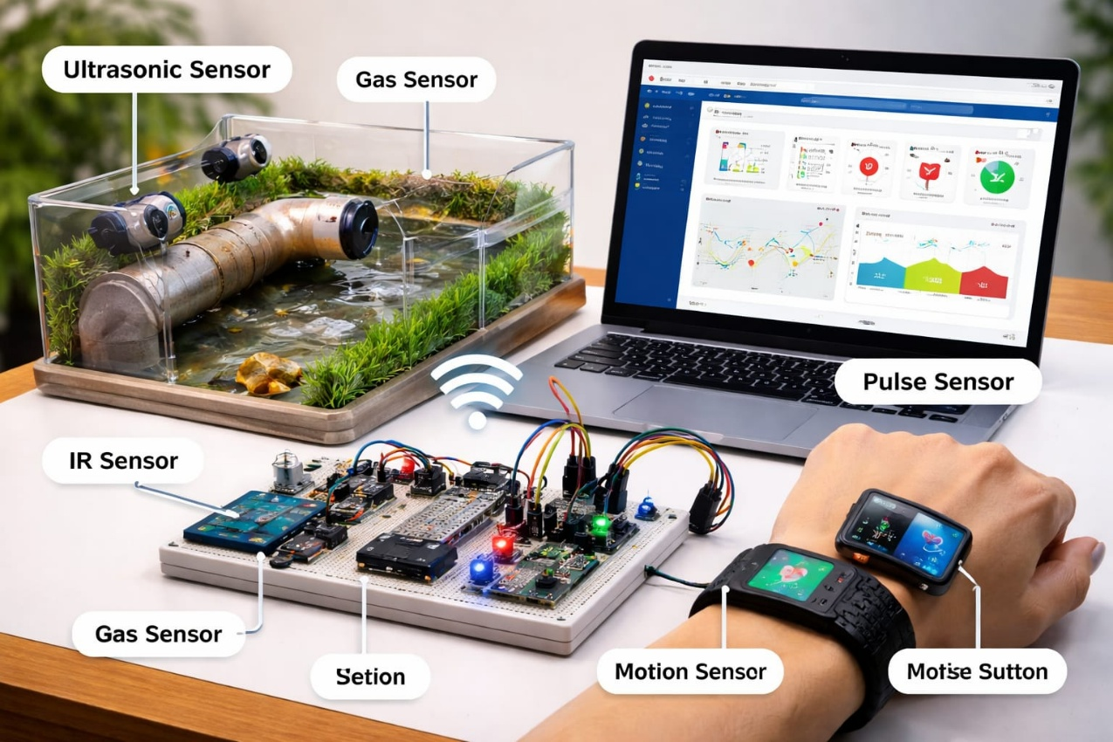
Figure 3.10 Design of Smart Drain
3.6 System Operation and Functional Overflow
The SafeDrain system operates as a continuous and automated monitoring system designed to ensure real-time detection of drainage conditions and worker safety. The overall workflow is structured in a cyclic manner, where data is continuously collected, processed, analyzed, and transmitted to the monitoring platform for further action. This ensures uninterrupted operation and timely response to critical situations.
The operation begins with the sensing phase, where all sensors deployed in the drainage system and wearable device collect real-time data. The ultrasonic sensor measures the water level at regular intervals, while the IR sensor detects the presence of blockages or solid waste. Simultaneously, the gas sensor monitors the concentration of harmful gases in the drainage environment. On the worker side, wearable sensors capture physiological parameters such as heart rate, body temperature, and movement. These readings are continuously updated to reflect the current condition of both the environment and the worker.
Once the data is collected, it is forwarded to the microcontroller for processing. The microcontroller converts analog signals into digital values, applies calibration techniques, and filters out noise to ensure accuracy. The processed data is then compared against predefined threshold values to identify abnormal conditions. For instance, if the water level exceeds a safe limit, it indicates a potential flooding condition. Similarly, detection of toxic gases or abnormal worker vitals triggers safety alerts.
In the next stage, the system performs decision-making based on the analyzed data. If all parameters are within safe limits, the system continues normal monitoring. However, if any parameter crosses the threshold, the system immediately categorizes it as a critical condition. Different types of alerts are generated depending on the situation, such as flood warnings, gas hazard alerts, or worker distress notifications.
Following this, the communication phase is initiated, where the ESP32 module transmits the processed data and alert information to the centralized monitoring dashboard. The data is sent in real time, ensuring that there is minimal delay between detection and reporting. In prototype mode, the system can display data on a local interface, while in real-world applications, it can be connected to cloud platforms for remote monitoring.
At the application level, the dashboard receives and displays the data in an organized and user-friendly format. Visual elements such as graphs, indicators, and heatmaps are used to represent the condition of different drainage locations and worker status. Color-coded risk levels (green for safe, yellow for warning, and red for critical) help authorities quickly identify problem areas and prioritize actions.
The system also includes an alert and response mechanism. When a critical condition is detected, notifications are generated to inform relevant authorities or supervisors. In the case of worker emergencies, the panic button in the wearable device allows manual alert triggering, ensuring immediate attention and response. This feature enhances safety and reduces response time in critical situations.
Finally, the system continues to operate in a loop, constantly updating data and monitoring conditions. This continuous workflow ensures that any changes in environmental or worker parameters are immediately detected and addressed. The integration of sensing, processing, communication, and visualization creates a reliable and efficient monitoring system capable of supporting modern urban infrastructure needs.

CHAPTER 4

RESULTS AND DISCUSSION

4.1 System Implementation
The SafeDrain system was successfully designed and implemented as a prototype model integrating both drainage monitoring and worker safety features. The hardware components, including sensors and microcontrollers, were assembled and tested under controlled conditions to evaluate system performance. The sensors were connected to the microcontroller unit, and the embedded software was programmed to collect and process real-time data.
The drain monitoring unit was configured to measure water levels, detect blockages, and identify the presence of harmful gases. The wearable safety device was also developed and tested to monitor worker health parameters such as heart rate, body temperature, and motion. All components were integrated into a single system to ensure seamless communication and operation.
The ESP32 module was used to establish wireless communication between the hardware system and the monitoring dashboard. Data collected from sensors was transmitted in real time and displayed on a web-based interface. The dashboard was designed to provide clear visualization of system parameters using graphs, indicators, and alert notifications.
The implementation phase also included calibration of sensors to ensure accurate readings. Different environmental conditions were simulated to test system reliability. The results confirmed that the system is capable of continuously monitoring drainage conditions and worker safety parameters effectively.
The implementation of the SafeDrain system also involved integrating multiple subsystems to ensure synchronized operation. Special attention was given to the interfacing of sensors with the microcontroller to avoid signal conflicts and ensure stable data acquisition. Each sensor module was tested individually before being integrated into the complete system, which helped in identifying and rectifying hardware-level issues at an early stage.
To improve system robustness, protective enclosures were considered for the sensors to prevent damage from water exposure, dirt, and corrosion in drainage environments. The wiring and connections were secured properly to maintain consistent performance even under rough conditions. The wearable safety module was designed to be compact and lightweight, ensuring ease of use for workers without affecting their mobility.
The dashboard implementation was carried out with a focus on usability and clarity. The interface was designed to display real-time updates without lag, and different data streams were organized in a structured format for easy interpretation. The system was also tested for continuous operation over extended periods to ensure stability and reliability.
4.2 Performance Analysis
The performance of the SafeDrain system was evaluated based on parameters such as accuracy, response time, reliability, and efficiency. The ultrasonic sensor demonstrated consistent performance in measuring water levels, with minimal deviation in readings. The system was able to detect rising water levels promptly and generate alerts when predefined thresholds were exceeded.
The IR sensor effectively identified blockages by detecting interruptions in the signal path. This allowed early identification of waste accumulation, reducing the chances of overflow. The gas sensor successfully detected the presence of harmful gases within the test environment, ensuring timely warnings for hazardous conditions.
The wearable device showed reliable performance in monitoring worker health parameters. Heart rate and temperature readings were accurately recorded, and abnormal values triggered immediate alerts. The motion sensor was effective in detecting inactivity, which can indicate potential danger or distress situations.
The communication system using the ESP32 module provided efficient real-time data transmission with minimal delay. The dashboard displayed updated information continuously, enabling quick interpretation and response. Overall, the system demonstrated good responsiveness and accuracy, making it suitable for real-time monitoring applications.
Further analysis of the system performance indicates that the SafeDrain system maintains stable operation under varying environmental conditions. The sensors demonstrated consistent output even when subjected to minor disturbances such as fluctuations in temperature and humidity. The system was capable of handling multiple sensor inputs simultaneously without significant delay in processing.
The response time of the system was observed to be within acceptable limits for real-time monitoring applications. Alerts were generated almost instantly when abnormal conditions were detected, which is crucial for preventing critical situations such as flooding or worker accidents. The efficiency of wireless communication was also evaluated, and it was found that data transmission remained stable within the operational range of the Wi-Fi network.
The system's reliability was tested by running it continuously for long durations. It was observed that the microcontroller handled data processing efficiently without overheating or performance degradation. The wearable device also maintained consistent readings over time, indicating its suitability for continuous health monitoring.
Overall, the system demonstrated a good balance between accuracy, speed, and reliability, making it a practical solution for real-world deployment

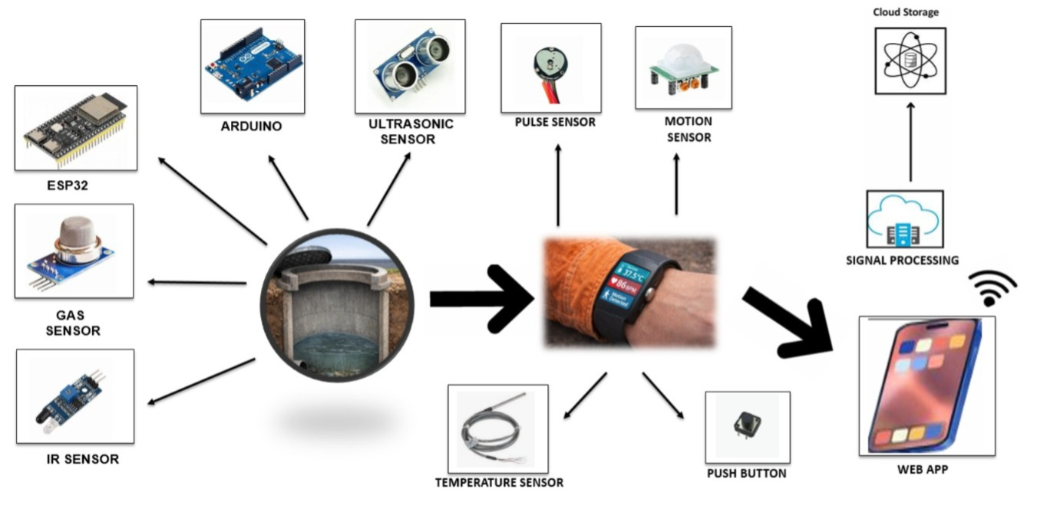
Figure 4.1 Block Diagram of SafeDrain System

4.3 Discussion
The results obtained from the implementation and testing of the SafeDrain system indicate that the proposed solution is effective in addressing the challenges of urban drainage monitoring and worker safety. The integration of multiple sensors allows comprehensive monitoring of environmental and physiological parameters.
Compared to traditional systems, the SafeDrain system offers significant improvements in terms of real-time monitoring, early detection, and automated alert generation. The ability to monitor multiple parameters simultaneously enhances system reliability and efficiency. The inclusion of a wearable safety device adds an additional layer of protection for workers, which is often missing in conventional systems.
The system also demonstrates scalability, as additional sensors and monitoring units can be easily integrated into the existing framework. The use of IoT technology enables remote monitoring and centralized data management, making it suitable for smart city applications.
However, certain limitations were identified during testing. Sensor performance may be affected by environmental factors such as moisture, temperature variations, and interference. Proper calibration and protective measures are required to ensure long-term reliability. Additionally, connectivity issues may arise in areas with poor network coverage, which can affect real-time data transmission.
Despite these challenges, the overall performance of the system is satisfactory, and the benefits outweigh the limitations. The SafeDrain system provides a practical and efficient solution for improving urban infrastructure management and ensuring worker safety.
The discussion of results highlights the practical significance of integrating IoT technology into urban infrastructure systems. The SafeDrain system not only improves monitoring efficiency but also introduces a proactive approach to problem management. By identifying issues at an early stage, the system helps in reducing maintenance costs and preventing large-scale damage.
Another important aspect observed is the enhancement of worker safety through continuous health monitoring. This feature ensures that any abnormal condition is detected immediately, reducing the risk of severe health hazards. The inclusion of an emergency alert mechanism further strengthens the safety framework by enabling quick response during critical situations.
The system also demonstrates the potential for future technological enhancements. Integration with cloud platforms, mobile applications, and advanced data analytics can further improve system capabilities. Predictive analysis using historical data can help in forecasting potential risks and planning preventive measures more effectively.
From an operational perspective, the system reduces dependency on manual inspection and minimizes human error. It enables authorities to monitor multiple locations remotely, improving overall efficiency and resource utilization. This makes the SafeDrain system a valuable contribution toward smart city development.

CHAPTER 5

FUTURE SCOPE AND CONCLUSION

5.1 Future Scope
The SafeDrain system provides a strong foundation for intelligent urban drainage monitoring and worker safety; however, there are several opportunities for further enhancement and expansion to improve its functionality and real-world applicability.
One of the major areas for future improvement is the integration of Global Positioning System (GPS) technology. By incorporating GPS modules, the system can provide precise location tracking of drainage units and workers. This will help authorities quickly identify the exact location of critical issues and respond more efficiently, especially in large urban areas.
Another significant advancement can be achieved through the use of Artificial Intelligence (AI) and Machine Learning (ML) techniques. By analyzing historical sensor data, the system can predict potential flooding conditions, detect patterns in drainage blockages, and provide early warnings. Predictive analytics can transform the system from a reactive model to a proactive and intelligent decision-making system.
The development of a mobile application can further enhance accessibility and usability. A dedicated mobile app can provide real-time notifications, system status updates, and remote control features for authorities and maintenance teams. This will allow users to monitor the system from anywhere, improving response time and operational efficiency.
The system can also be upgraded by incorporating solar power technology, making it energy-efficient and suitable for continuous operation in remote or power-limited areas. This reduces dependency on external power sources and ensures uninterrupted functionality.
Improving sensor technology is another important area for future work. Advanced sensors with higher accuracy and durability can be used to enhance performance in harsh environmental conditions. Waterproof and corrosion-resistant designs can increase the lifespan of hardware components deployed in drainage systems.
The SafeDrain system can also be expanded into a city-wide network, where multiple monitoring units are interconnected through cloud platforms. This will enable centralized data management, large-scale monitoring, and better coordination among municipal authorities.
Integration with smart city infrastructure is another promising direction. The system can be connected with other urban management systems such as traffic control, emergency services, and environmental monitoring to create a comprehensive and intelligent urban ecosystem.
Additionally, features such as automated cleaning mechanisms and robotic inspection systems can be incorporated in the future to further reduce human involvement in hazardous environments. This will significantly improve worker safety and operational efficiency.
Overall, the SafeDrain system has vast potential for enhancement, and future developments can make it a highly advanced and indispensable tool for urban infrastructure management.

5.2 Conclusion
The SafeDrain system presents an innovative and practical solution to the challenges associated with urban drainage management and sanitation worker safety. By integrating IoT technology, multiple sensors, and real-time data communication, the system provides continuous monitoring and early detection of critical conditions such as water overflow, blockages, and toxic gas presence.
The implementation of the system demonstrates its ability to effectively collect, process, and transmit data, enabling authorities to make informed decisions and take timely action. The inclusion of a wearable safety device adds a significant advantage by ensuring the health and safety of sanitation workers, which is often neglected in traditional systems.
The results obtained from testing and analysis confirm that the system is reliable, efficient, and capable of operating in real-time environments. It reduces dependency on manual inspection, minimizes human error, and enhances overall operational efficiency. The use of a centralized dashboard with visual representation further improves monitoring and decision-making capabilities.
Despite certain limitations such as sensor calibration challenges and connectivity issues, the overall performance of the system is satisfactory. These limitations can be addressed through future enhancements and technological advancements.
The SafeDrain system aligns with the goals of smart city development by promoting sustainable, efficient, and technology-driven urban management solutions. It not only improves infrastructure monitoring but also prioritizes human safety, making it a comprehensive solution for modern urban challenges.
In conclusion, the SafeDrain system successfully demonstrates how IoT-based innovations can transform traditional systems into intelligent and proactive solutions. With further development and large-scale implementation, it has the potential to significantly improve urban living conditions and contribute to safer and smarter cities.

REFERENCES
- A. Kumar and A. K. Singh, "IoT-based Air Pollution Monitoring System for Smart City," IEEE Internet of Things Journal, vol. 6, no. 2, pp. 1303-1310, Apr. 2019.
- M. S. Hossain, M. Fotouhi, and R. Hasan, "Towards End-to-End Secure Knowledge-Driven Decision-Making in IoT-Based Smart Cities," IEEE Internet of Things Journal, vol. 6, no. 3, pp. 5231-5244, Jun. 2019.
- A. R. Zolanvari, A. Jalali, B. M. Sadoughi, M. Abawajy, and D. Nourifard, "Smart Cities Development with a Real-Time Air Quality Monitoring Network," Proc. IEEE Int. Conf. Smart Cities (ISC2), 2018, pp. 19-23.
- S. Jiang, B. Shao, and J. Zhang, "Design of an IoT-based Air Quality Monitoring System," IEEE Sensors Journal, vol. 19, no. 10, pp. 3779-3786, May 2019.
- J. M. Marques, L. Almeida, and R. Alves, "Real-time Environmental Monitoring Based on Wireless Sensor Networks: A Review," Proc. IEEE Conf. on Green Energy and Systems, 2020, pp. 1-6.
- Z. Tao, H. Lin, and K. Chen, "Embedded System Design for Environmental Monitoring in Smart Cities," IEEE Embedded Systems Letters, vol. 12, no. 4, pp. 92-95, Dec. 2020.
- R. Kumar, A. Singh, and S. K. Singh, "Smart Environmental Monitoring System Using IoT and Cloud," Proc. IEEE Int. Conf. on Intelligent Communications and Computational Technologies, 2021, pp. 123-128.
- N. Jain and N. Nair, "Development of IoT Based Multi-Parameter Environmental Monitoring System," IEEE Sensors Applications Symposium, 2021, pp. 1-5.
- A. S. F. Inam and M. S. M. Saqlain, "Low-Cost Smart Air Quality Monitoring System Using ESP32," Proc. IEEE International Symposium on Circuits and Systems, 2022.
- L. Zhang, Q. Fang, and S. Ma, "Real-time Air Quality Monitoring System Based on Wireless Sensor Network and Cloud Platform," IEEE Access, vol. 8, pp. 13215-13226, 2020.
- S. Patel and M. Gupta, "IoT Based System for Smart Environmental Monitoring," Proc. IEEE Int. Conf. on Advances in Computing, Communication and Control, 2019, pp. 567-572.
- J. W. Lee, Y. Y. Kim, and B. H. Cho, "Design and Implementation of a Real-time Smart Environmental Monitoring System Using IoT," IEEE Sensors Journal, vol. 20, no. 14, pp. 8087-8096, Jul. 2020.
- H. Wang, X. Chen, and W. Zhang, "An Embedded System Prototype for Indoor Air Quality Monitoring Based on IoT," Proc. IEEE Conf. on Embedded Systems, 2021, pp. 210-214.
- P. Ranjan, P. Sharma, and S. Kumar, "A Wireless Sensor Network based Environmental Monitoring System for Smart Homes," IEEE Transactions on Consumer Electronics, vol. 65, no. 3, pp. 335-344, Aug. 2019.

